Check Code: Customizing the Data Entry Process

Introduction

The Check Code tool allows users to customize the data entry process. It is useful to check for errors during the data entry process, to do automatic calculations in fields, and to skip over parts of the questionnaire if certain conditions are met. Check Code makes it possible to instruct the Enter tool to perform such operations automatically. By using Check Code, you can protect data against many common types of errors by setting rules for data entry. Check Code is created using the Check Code Editor.
Examples of operations that can be performed in Check Code include:
- Displaying messages that appear to be part of the questionnaire
- Calculating fields from mathematical operations
- Checking one or more fields for relationships (e.g., making sure birth date is earlier than current date)
- Checking fields for inconsistencies (e.g., male pregnancies)
- Displaying error messages due to improper entries in a field
- Complex statistics or other operations that are written in other languages
- Automatic indexing of fields for faster searching
- Automatic searches during data entry
An operation can be performed automatically each time data is entered in a field or conditionally when a certain value is entered. Check code is optional and is designed to allow the user to provide customized data entry processes.

Accessing Check Code Program Editor

To navigate to the Check Code Program Editor, click the Check Code button in the Form Designer tool bar after opening your Epi Info 7 project.

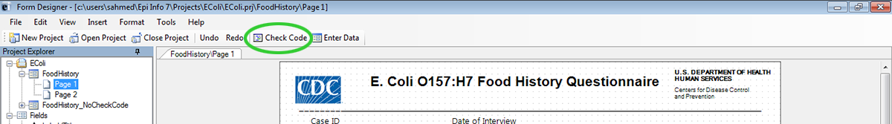
Figure 3.1: Check Code button

Alternatively, select Tools > Check Code Editor from the Form Designer navigation menu.
Figure 3.2: Form Designer Menu

Navigate the Check Code Program Editor

The Check Code Editor window contains four sections:
- Choose Field Block for Action
- Add Command to Field Block
- Program Editor
- Messages
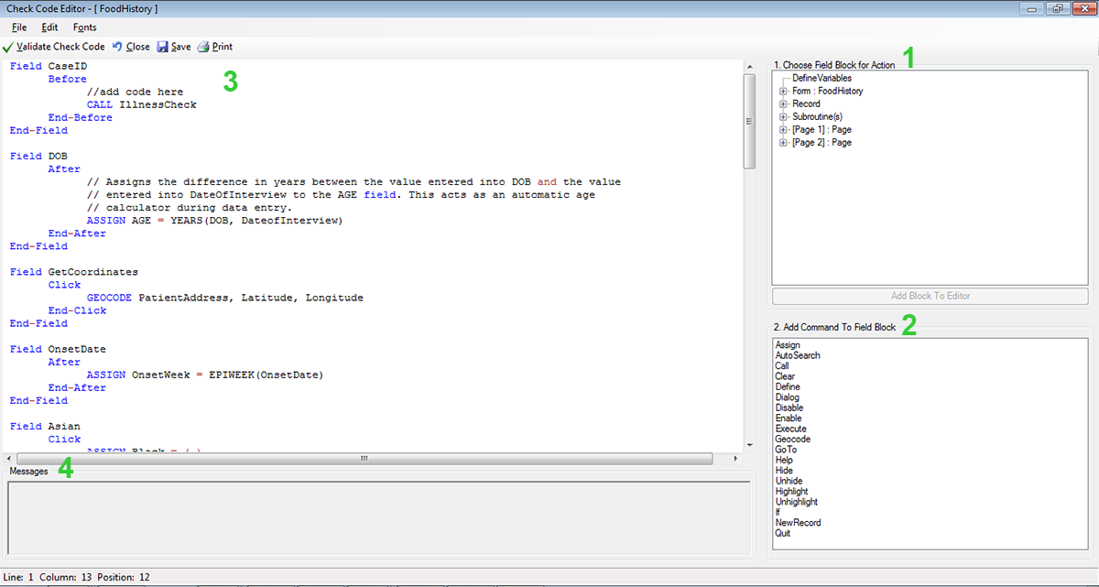
Figure 3.3: Check Code Program Editor
- The Choose Field Block for Action tree allows you to select fields and sets when the actions designated by the Check Commands occur during data entry.
- The Add Command to Field Block window displays all the available check commands used in the Form Designer program.
- The Program Editor window displays the code generated by the commands created from the Choose Field Block for Action or Add Command to Field Block window. Code can also be typed and saved directly into the Program Editor.

- The Message window alerts you of any check command problems

There are several options on the toolbar at the top left that allow you to save, edit, validate and change the font of your program editor. You can close the Check Code Editor and return to your form by clicking on the red X button at the top right of your screen, clicking on the Close button, or by pressing the F10 key.

Check Code Commands

Check commands are structured in blocks. Each block begins with a field, page or form name and ends with the word END. All commands must be within a field-name block. Commands in a block are usually activated either before or after an entry is made in the field. For some field types, blocks can also be activated when clicking on the control (i.e. checkboxes and command buttons). The usual case is that the commands are performed after an entry has been made and the user has pressed the <ENTER> key or when the cursor has left the field automatically. This behavior can be altered by placing commands in blocks called BEFORE. The format of check code blocks is usually structured as follows:

Field VARIABLENAME
After
Check Code syntax inserted here
End-After
End-Field
- The FIELD parameter establishes to which field name the check code block corresponds.
- The AFTER parameter specifies when the action will occur. The AFTER event is executed as soon as the cursor leaves that field.
- The END-AFTER parameter specifies the closing of the commands to be executed, in this example, for the AFTER event. In other words, any check code inserted between the AFTER and END-AFTER section will be executed for that field after the cursor leaves the field.
- The END-FIELD parameter simply closes the block of commands incorporated for the corresponding field.
In the example below, we have incorporated an AFTER event for a field called DOB. The block of check code will execute the assignment of a value to the field AGE using the YEARS function. The YEARS function will calculate the difference between two date fields and provide the result in Years.

Field DOB
After
ASSIGN AGE=YEARS(DOB,SYSTEMDATE)
End-After
End-Field

Basic Check Code Command Rules
- Check Commands must be placed in a block of commands corresponding to a variable/field in the database. Special sections are provided to execute commands before or after you display a form, page, or record.
- Comments preceded by two forward slashes ("//") may be placed within blocks of commands and will be ignored during execution of check code.
- Commands in a block are activated before or after you make an entry in the field. By default, commands are performed after an entry has been completed with <Enter>, <PgUp>, <PgDn>, or <Tab>, or another command causes the cursor to leave the field (e.g., GOTO). Commands can also be activated when clicking on a field or when selecting a value from a drop down list (versions 7.1.4 or higher only).
- Check commands for each field are stored in the form in a record associated with a particular field.
- Commands are inserted automatically through interaction with the dialog boxes. The syntax generated by the dialogs is then displayed in the Check Code Editor. Text can also be edited and saved in the Program Editor.
- BEFORE and AFTER commands can be inserted into fields but also into a form, page or a record.

Creating a Check Code Block
- From Choose Field Block for Action, select and expand the form, page, record, or field that will receive the commands. Expand by clicking the + sign.

Figure 3.4: Choose Field Block for Action

- Select whether the command will be executed before or after data entry into the form, page, record, or field by clicking in the corresponding option (in this example AFTER).
Figure 3.5: Add Block
- You can either double click on the AFTER event or click the Add Block button in order to insert the block. The Check Code Block appears in the Check Code Editor.

Figure 3.6: Code Block Added to Editor
After a Check Code Block has been created for a form, page, record, or field, you can insert commands within the block using the Add Command to field Block section.

Create a Skip Pattern with GOTO
You can create skip patterns by changing the tab order and setting a new cursor sequence in a form, or by creating Check Code using the GOTO command. Skip patterns can also be created based on the answers to questions using an IF/THEN statement. In the following example, we will add check code to move the cursor to the Ethnicity field after data is entered into the DOB field.
- From Form Designer, Open the Ecoli.prj project.
- Double click on the FoodHistory_NoCheckCode form.
- Click Check Code or select Tools > Check Code Editor. The Check Code Editor opens.
- From the Choose Field Block for Action section, expand the node for Page 1 to see the various fields on the first page.
- Expand the node for the field DOB.

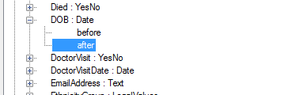
Figure 3.7: Dialog Block for Action after DOB
- Double click on the after event.
- A block of code for the DOB field will display in the Check Code Editor.

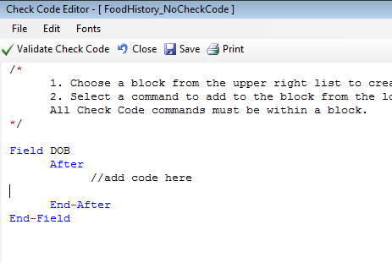
Figure 3.8: Check Code Block for Action After DOB
- Click GoTo from the Add Command to Field Block list box. The GOTO dialog box opens.
- Select the EthnicityGroup field for the cursor to jump into after data has been entered in the DOB field. The code will run after the cursor leaves the field.

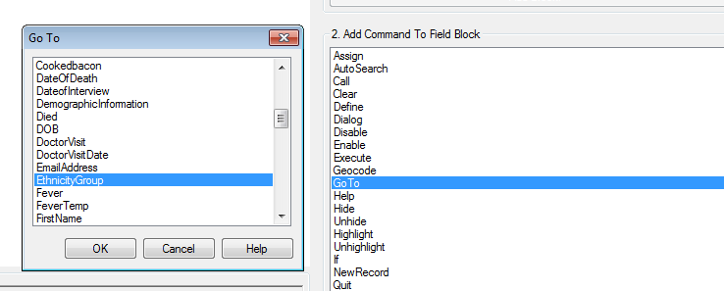
Figure 3.9: Skip Pattern Go To dialog box

- Click OK. The code appears in the Check Code Editor.

Figure 3.10: Skip Pattern Check Code Command
- Click the Verify Check Code button from the Check Code Editor.
- Click the Save button from the Check Code Editor.
- Click Close to return to the form.

To test the skip pattern, open the form in the Enter Data tool. Use the tab key to ensure that upon leaving the field with the GOTO command, the cursor goes to the specified field.

Create a Skip Pattern Using IF/THEN and GOTO
Use IF/THEN statements to create skip patterns based on the answers to questions in the form. This example creates code, which states that if the person answered No (-) for the Hospitalized field, then the cursor subsequently jumps to the field Was the patient treated with antibiotics? and skips the Hospital Admission date field.

- From Form Designer, Open the Ecoli.prj project.
- Double click on the FoodHistory_NoCheckCode form.
- Click Check Code or select Tools > Check Code Editor. The Check Code Editor opens.
- From the Choose Field Block for Action section, expand the node for Page 1 to see the various fields on the first page.
- Expand the node for the Hospitalized field.
- The action needs to occur after data are entered into the Hospitalized field.
- Double click on the after event.
- A block of code for the Hospitalized field is created and displayed in the Check Code Editor.

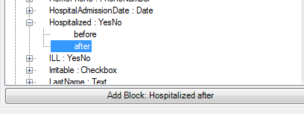
Figure 3.11: Dialog Block for Action after Hospitalized
- The code appears in the Check Code Editor.
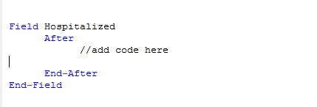
Figure 3.12: If/Then Block Code After Hospitalized
- Click If from the Add Command to Field Block list box. The IF dialog box opens.
- From the Available Variables drop-down list, select the field to contain the action. For this example, select Hospitalized. The selected variable appears in the If Condition field.
- From the Operators, click =.
- From the Operators, click No. The If Condition field will read Hospitalized=(-).
- Click the Code Snippet button in the Then section. A list of available commands appears.
- From the command list, select GoTo. The GOTO dialog box opens.
- Select the field for the cursor to jump to based on a No answer from the list of variables. For this example, select Antibiotics.
- In the GOTO dialog box, click OK to return to the IF dialog box.

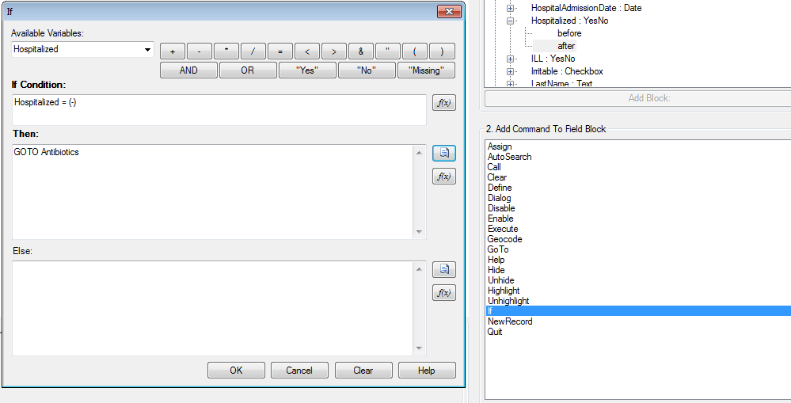
Figure 3.13: If/Then dialog box
- Click OK. The code appears in the Check Code Editor. The example code appears as:

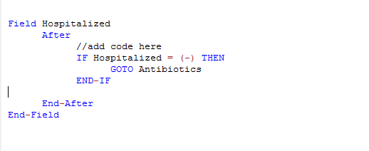
Figure 3.14: If/Then Check Code Command
- Click the Verify Check Code button from the Check Code Editor.
- Click the Save button from the Check Code Editor.

Using Functions with a Date field
To program a mathematical function, use the Program Editor and the ASSIGN command. For example, Check Code can be created to automatically calculate the age of a respondent based on the date of birth and the date the form was completed, or the system date of the computer when data were entered.
This example uses a field called DateOfBirth and a field called Age from the FoodHistory_NoCheckCode form in the Ecoli project to demonstrate the use of the ASSIGN command and the function YEARS.
- Click Check Code or select Tools > Check Code Editor. The Check Code Editor opens.
- From the Choose Field Block for Action section, expand the node for the page where the DateofBirth field is located.
- Expand the node for the DateofBirth field.
- Double click on the after event.
- A block of code for the DateofBirth field is created and displayed in the Check Code Editor.
- Click Assign from the Add Command to Field Block list box. The Assign dialog box opens.
- From the Assign Variable drop-down list, select the field where the calculated value should appear. For this example, select the Age field.
- Click on the functions button.
- Select the Date Functions option.
- Click on the YEARS function.
- Double click on the <start_date> parameter. This will highlight that section of the command.
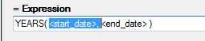
Figure 3.15: Start Date Parameter
- Select DateOfBirth from the list of Available Variables
- Double click on the <end_date> parameter. This will highlight that section of the command.
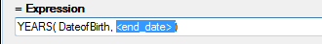
Figure 3.16: End Date Parameter
- Click on the functions button.
- Select the System Functions option.
- Click the SYSTEMDATE function. Once completed, the syntax will be inserted on the dialog window.

Figure 3.17: Assign Date Function options
Figure 3.18: Assign dialog box
- Click OK. Check Code will appear in the Check Code Editor.
- Click the Verify Check Code button in the Check Code Editor.
- Click the Save button in the Check Code Editor.

Figure 3.19: Assign Check Code Command
When Date of Birth is entered into the form, the Age field will automatically populate.

Figure 3.20: Assignment of Age in Enter Data

Interact with Users with the DIALOG command
The DIALOG command provides interaction with data entry personnel from within the program. Dialogs can display information, ask for and receive input, and offer lists to make choices. In the following example, the DIALOG command creates a reminder that all fields on page two of the survey must be completed.
- From Form Designer, Open the FoodHistory_NoCheckCode form in the EColi.prj.
- Click Check Code or select Tools > Check Code Editor. The Check Code Editor opens.
- From the Choose Field Block for Action list box, select Page 2. The action should occur before the page is loaded.
- Select Before from the Before or After Section.
- Click the Add Block button.

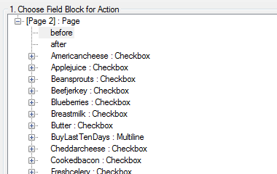
Figure 3.21: Dialog Block for Action
- The code appears in the Check Code Editor.

Figure 3.22: Dialog Block Code
- From the Add Command to Field Block list box, select Dialog. The DIALOG box opens.
- Select Simple from the Dialog Type radio button options.
- In the Title field, type Alert.
- In the Prompt field, type All fields on page two must be completed.

Figure 3.23: Dialog command box
- Click OK. The code appears in the Check Code Editor.

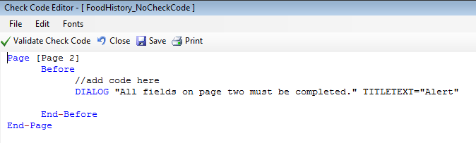
Figure 3.24: Dialog Check Code Command
- Click the Verify Check Code button from the Check Code Editor.
- Click the Save button in the Check Code Editor.

Searching for Records – Using the AUTOSEARCH command
The Autosearch command automatically searches for an existing record that matches the entered values and notifies the user. A choice is then offered between editing the matching record or continuing with data entry in the new record. Duplicate records are detected and may be prevented with the AutoSearch command. For this example, we will incorporate the Autosearch command on the CaseID field.
- From Form Designer, Open the FoodHistory_NoCheckCode form in the EColi.prj.
- Click Check Code or select Tools > Check Code Editor. The Check Code Editor opens.
- From the Choose Field Block for Action section, expand the node for the page where the CaseID field is located, which in this example is Page 1.
- Expand the node for the field CaseID.
- Double click on the after event.
- A block of code for the CaseID field is created and displayed in the Check Code Editor.

Figure 3.25: AutoSearch Block for Action
- The code appears in the Check Code Editor.

Figure 3.26: AutoSearch Block Code
- From the Add Command to Field Block list box, click Autosearch. The Autosearch window opens.
- Select the variable(s) to be searched during data entry. In this example, select CaseID.

Figure 3.27: Auto Search dialog box
- Click OK. The code appears in the Check Code Editor window.

Figure 3.28: AutoSearch Check Code Command
- Click the Verify Check Code button from the Check Code Editor.
- Click the Save button from the Check Code Editor.
- .Click Close to return to the form.
When a duplicate record is entered in the Enter Data tool, the Autosearch dialog box opens with all the matching records listed. To view the potential duplicate record, double-click the arrow that appears next to the record. The field where the potential duplicate was entered is cleared. Alternatively, click Cancel to remain on the current record and accept the duplicate value. To display other variables when a matching record is found, add the variable names after the DISPLAYLIST parameter (i.e. Last Name, First Name and Date of Birth as shown below).

Field CaseID
After
//add code here
AUTOSEARCH CaseId DISPLAYLIST CaseID LastName FirstName DOB
End-After
End-Field

In the check code above, the autosearch will be done on the field CaseID and if any matching records are detected, the fields CaseID, LastName, FirstName and DOB will be displayed on the grid.

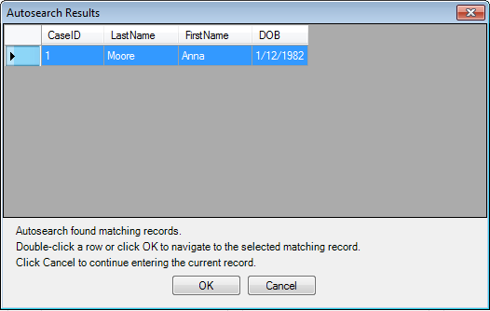
Figure 3.29: Autosearch Results
Note: For more information on using Autosearch, please see the Autosearch topic in the Command Reference.

Copy the Value of a Field from a Main Form to a Related Form
When users have developed a relational database setup using Epi Info™ 7, it might be appropriate to transfer values entered in the parent form (i.e. core demographics) into the child form (i.e. Visits information). In order to accomplish this process, Check Code must be created for a value from a field in the main form to appear in a related form (i.e., there may be a Case ID Number or Patient’s Name that needs to be visible in the parent and child forms).

The following instructions assume the parent and child forms already exist. Let’s assume that the Parent form is called Surveillance while the Child form is called Hepatitis. The field to be copied needs to exist in the parent form or be created in the parent form prior to the incorporation of the check code in the child form (i.e. Last Name in parent form will be passed to Last Name in child form). Let’s make the assumption that the name of the field on the Parent form whose value will be copied to the Child form is called PatientId.
- From Form Designer, open your project and click on the child form name from the Project Explorer tree.
- Create a new field. The new field must be the same field type as the field being copied from the parent form. For this example, use PatientId.
- Select the Read Only option.
- Click OK. The new field appears in the form. This is where the value from the parent form will be assigned and displayed during data entry on the child form.
- Click Check Code or select Tools > Check Code Editor. The Check Code Editor opens.
- From the Choose Field Block for Action list box, select the page corresponding to where the PatientId field was placed. Let’s make the assumption that this field was created on Page 1. For the Page, select the before from the Before or After Section.
- Click the Add Block button.
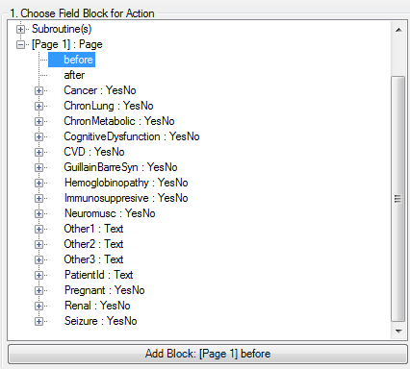

Figure 3.30: Choose Field Block for Action
- From the Add Command to Field Block list box, click Assign. The ASSIGN dialog box appears.
- From the Assign Variable drop-down list, select the new variable, PatientId.
- In the = Expression area, type the field name from the parent form, in this case PatientId. This field name must be prefixed by the parent form’s name followed by a period in the Assign expression. We will need to make that modification once the command is written into the Program Editor.:

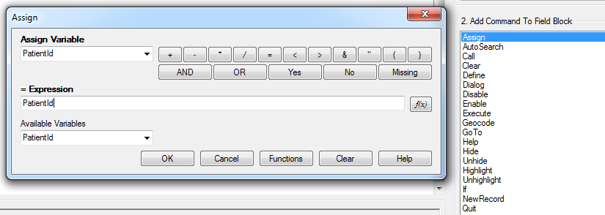
Figure 3.31: Copy Value- Assign dialog box
- Click OK.
- The code appears in the Check Code Editor. If the child form already has a field with the same name as the one being copied from the parent form, it is important to distinguish the parent’s field name. This field name must be prefixed by the parent form’s name followed by a period in the Assign expression. In this example, Hepatitis is the name of the child form while Surveillance is the name of the parent form. If the child form does not have a field with the same name as the one being copied from the parent form, it is sufficient to indicate just the field name. Therefore, for this example, this modification will be required to the syntax since the field is called the same on both forms. Once completed, your syntax should look like the one on Figure 3.32.
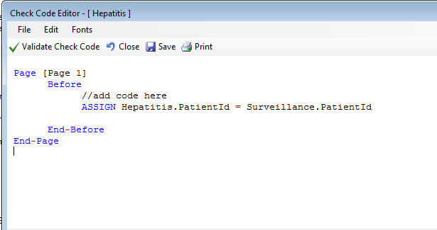
Figure 3.32: Copy Value Check Code Command
- Click the Validate Check Code button and, if needed, correct any issues.
- Click Save.

Concatenate Fields
When writing check code for concatenating fields, syntax will be executed for new records entered. The code will not go back and populate previously entered data. If previously entered data need to be concatenated, use concatenation commands from the Classic Analysis section of the manual.

Concatenate Fields with the Ampersand '&' Operator
This example illustrates how to join data from two fields and assign it into a third field using the ‘&’ operator. In this example, Patient Full Name will be assigned to the concatenation of First Name and Last Name.
- In Form Designer, open your form.
- Click Check Code. The Check Code Editor opens.
- From the Choose Field Block for Action list box, select LastName.
- Select after from the Before or After Section.
- Click the Add Block button.
- From the Add Command to Field Block list box, click Assign. The ASSIGN dialog opens.
- From the Assign Variable drop-down list, select the field to contain the concatenated value.
- Create the = Expression using the '&' operator. In this example, ASSIGN PatientFullName = FirstName & LastName.

Figure 3.33: Concatenate- Assign dialog box
- Click OK. Check Code appears in the Check Code Editor.

Figure 3.34: Concatenate No Space Check Code Command
- Click the Validate Check Code button and correct any issues.
- Click Save.

If in the Enter tool, Carl was entered for FirstName and Gao was entered for LastName, the result of PatientFullName would be CarlGao. There are no spaces between the names. To add a space between the names, simply modify the ASSIGN statement by adding a blank space in quotes between the first and last names as in the following statement:
Figure 3.35: Concatenate Include Space Check Code Command

Concatenate Fields with the Substring Function
This example illustrates how to join parts of two variables to create a unique text ID. In this example, you will create a Patient ID made up of parts of the patient's last and first name. The ampersand (&) operator is used to join the two parts together.
Figure 3.36: Enter Form - Name
- From the Form Designer, click Check Code. The Check Code Editor opens.
- From the Choose Field Block for Action list box, select FirstName.
- Select after from the Before or After Section.
- Click the Add Block button.
- From the Add Command to Field Block list box click Assign. The ASSIGN dialog box opens.
- From the Assign Variable drop-down list, select the field to contain the concatenated value. In this example, select PatientID.
- Create the =Expression using the SUBSTRING syntax.
- SUBSTRING(<variable>, position #, #characters)
- <variable> is the field or variable
- position # is the position of the first character to be extracted from the variable
- #characters is the number of characters to extract
In this example, the PatientID variable contains a combination of the first position and four characters of the last name plus the first position and three characters of the first name.

Figure 3.37: Concatenate with Substring Assign dialog box
- Click OK. The code appears in the Check Code Editor window.
Figure 3.38: Concatenate with Substring Check Code Command
- Click the Validate Check Code button and correct any issues.
- Click the Save button.

The example functions as such:

- Last Name: Smith
- First Name: Megan
- Patient ID: SmitMeg
- The Patient ID field being calculated is Read Only.

Figure 3.39: Concatenate with Substring Enter Form

Create Check Code for Option Box Fields
Check Code can be added to option box variables. Code can be added to any line/choice present in the option boxes. Use the Check Code Editor to create complex Check Code for option box variables.
For this example, the check code created uses the GOTO command. Check Code was used to create the following scenario. If the answer to TestOptions is Choice 1, the cursor will jump to Question 2. If the answer to TestOptions is Choice 2 or Choice 3, the cursor will jump to Question 1. Check the tab order before creating the Check Code to ensure that the tab order is correct.
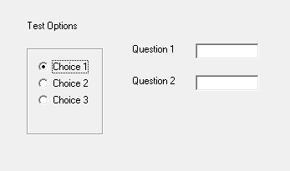
Figure 3.40: Text Options box
- Create an Option Box in a form. Note the name of the variable.
  - The variable is named TestOptions.
  - Each text line that represents a choice in the form represents a numeric position in the Check Code Editor.
  - For example, there are three lines/choices that can be made in the variable TestOptions. In the Check Code Editor the choices are numeric, choice 1 = position 0, choice 2 = position 1, and choice 3 = position 2.
- Open the Check Code Editor.
- From the Choose Field Block for Action list box, select TestOptions.
- Select after from the Before or After Section.
- Click the Add Block button.
- From the Add Command to Field Block list box, click If. The IF dialog box opens.
- From the If Condition field, type Test Options = 1.
- Remember that the number 1 in this instance represents a text value called Choice 2.
- Click the Code Snippet button in the Then section. A list of available commands appears.
- From the command list, select GoTo. The GOTO dialog box opens.
- Select Question2.
- Click OK.
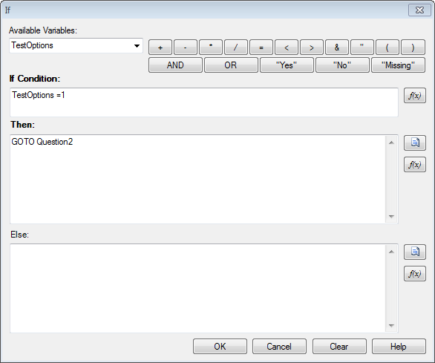
Figure 3.41: If dialog box
- Click Validate Check Code and correct any issues.
- Click Save.

Delete a Line of Code from the Check Code Editor
To delete a line(s) of check code from the Check Code Editor, you can complete the following steps:

- Highlight the line(s) of code/text that you desire to delete.
- Press the Delete key on your keyboard.
- Once done, from the Check Code Editor toolbar, click Save.

Note: Be sure of all deletions made. No confirmation prompt or undo button will appear prior to deletion.

Disable
If there isn’t a need to capture information for a particular field, then it can be disabled. Disable is usually used with the IF, THEN, ELSE conditions. In this example, the field DoctorVisitDate will be disabled if the response to the DoctorVisit is No.
- Open the FoodHistory_NoCheckCode form in the EColi.prj.
- Click Check Code. The Check Code Editor opens.
- Select the DoctorVisit from the Choose Field Block for Action list box.
- Select after from the Before or After Section.
- Click the Add Block button.
Figure 3.42: Disable Block for Action
- The code block appears in the Check Code Editor.
Figure 3.43: Disable Block Command
- Click IF from the Add Command to Field Block list box. The IF dialog box opens.
- From the Available Variables drop-down list, select the field to contain the action. For this example, select DoctorVisit. The selected variable appears in the If Condition field.
- From the Operators, click =.
- From the Operators, click No. The If Condition field will read DoctorVisit=(-).
- Click the Code Snippet button in the Then section. A list of available commands appears.
- From the command list, select DISABLE. The DISABLE dialog box opens.
- Select the field to be disabled based on a No answer from the list of variables. For this example, select DoctorVisitDate.
- Click OK to return to the IF dialog box.
- Click the Code Snippet button in the Else section. A list of available commands appears.
- From the command list, select Enable. The Enable dialog box opens.
- Select the field to enable based on a Yes answer from the list of variables. For this example, select DoctorVisitDate.
- In the Enable dialog box, click OK to return to the If dialog box.
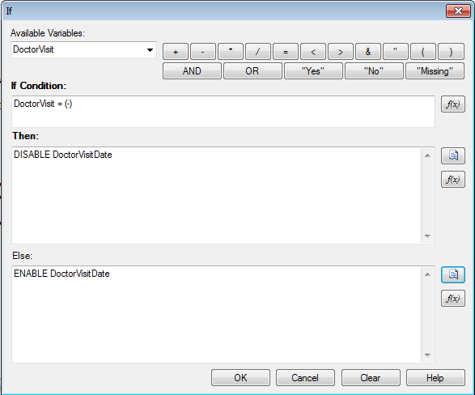
Figure 3.44: Disable- If dialog box
- Click OK. The code appears in the Check Code Editor. The example code appears as:

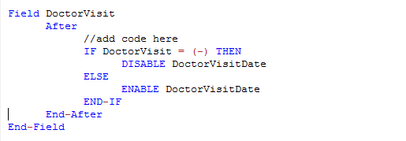
Figure 3.45: Disable Check Code Command
- Click Verify Check Code button.
- Click Save.
- Click Close to return to the form.

To test the Disable, open the form in the Enter Data tool. When No is entered for DoctorVisit, DoctorVisitDate should become disabled.

Hide
A field may be hidden if there is not a need to capture information for a particular field or if it does not apply based on previously answered questions. The field on the form would be hidden from the form. In the following example, the Pregnant option box will be hidden based on the users Sex; Female or Male.
- Click Check Code. The Check Code Editor opens.
- Select Sex from the Choose Field Block for Action list box.
- Select after from the Before or After Section.
- Click the Add Block button. This creates code to run after data is entered and accepted.
- The code appears in the Check Code Editor.
- Click IF from the Add Command to Field Block list box. The IF dialog box opens.
- From the Available Variables drop-down list, select the field to contain the action. For this example, select Sex. The selected variable appears in the If Condition field.
- From the Operators, click =.
- From the If Condition field, type Sex = “Male”. Remember that Sex is a text field and the value must be enclosed in quotes.
- Click the Code Snippet button in the Then section. A list of available commands appears.
- From the command list, select Hide. The Hide dialog box opens.
- Select Pregnant.
- Click OK.
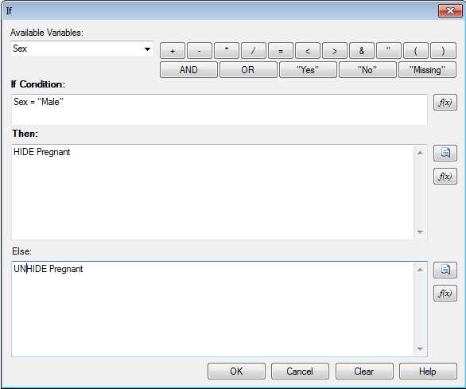
Figure 3.46: Hide- If dialog box
- Click the Code Snippet button in the Else section. A list of available commands appears.
- From the command list, select UNHIDE. The Unhide dialog box opens.
- Select the field to enable based on a Yes answer from the list of variables. For this example, select Pregnant.
- In the Unhide dialog box, click OK to return to the If dialog box.
- Click OK.
- Click OK. The code appears in the Check Code Editor.
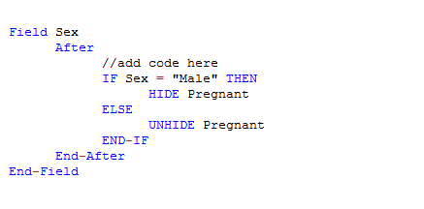
Figure 3.47: Hide Check Code Command
- Click the Save button.
- Click Close to return to the form.

Note: The Unhide command will display any hidden fields. You can select this command in the Add Command to Field Block section of the Check Code Editor. It is recommended to also incorporate a CLEAR command with the HIDE command in order to set null any information previously entered into the Pregnant field.

Geocode
The Geocode command uses the text entered into Address to retrieve and populate Latitude and Longitude coordinates into your form.
- From Form Designer, Open the FoodHistory_NoCheckCode form in the EColi.prj.
- Click Check Code. The Check Code Editor opens.
- Select GetCoordinates from the Choose Field Block for Action list box.
- Select Click.
- Click the Add Block button. This creates code to run after the Get Coordinates command button is clicked.
Figure 3.48: Geocode Block for Action
- The code appears in the Check Code Editor.
- Select Geocode from the Add Command to Field Block list box. The Geocode dialog box opens.
- From the Address drop-down list, select Address.
- From the Latitude drop-down list, select Latitude.
- From the Longitude drop-down list, select Longitude.
Figure 3.49: Geocode dialog box
- Click OK.
- Click OK. The code appears in the Check Code Editor.

Figure 3.50: Geocode Check Code Command
- Click the Save button.
- Click Close to return to the form.

When the Get Coordinates command button is clicked after an address is entered into your form in the Enter Data tool, the Geocode Results dialog will appear.

Figure 3.51: Geocode Enter Data Before
The Geocode Results dialog box contains, the Address entered into the form along with the Latitude and Longitude coordinates of that address. The confidence and quality of the geocoding service coordinates are also displayed.

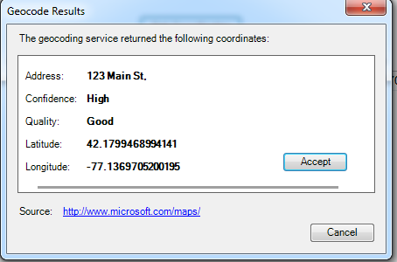
Figure 3.52: Geocode Results
After clicking Accept in the Geocode Results dialog box, the coordinates provided by the geocoding service are copied into the Latitude and Longitude fields in your form.

Figure 3.53: Geocode Enter Data After

Additional Check Code Commands

Call
This command redirects to another command block in check code and returns after it has been executed. This command is commonly used with subroutines. Subroutines act as a unit of common check code, which is usually dependent on two variables. The benefit of using subroutines is that it allows maintenance of check code in one common location. Here is an example of a subroutine:

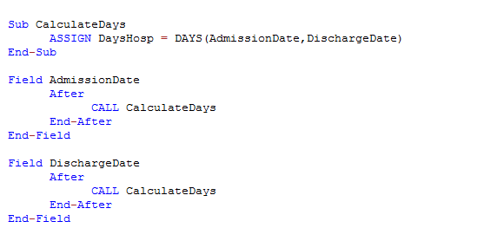
Figure 3.54: Check code syntax for Subroutines

In the example above, the calculation of days hospitalized would have been required to be placed in the AFTER event of the Admission Date and Discharge Date fields. However, through the usage of subroutines, users can update and maintain check code only in one location. By using the CALL command, the block of check code will execute when data are entered or updated in either field.

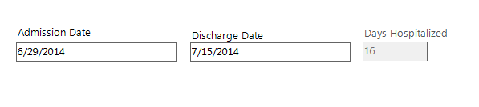
To create a subroutine, complete the following steps:
- From Form Designer, Open your form.
- Click Check Code. The Check Code Editor opens.
- From the Choose Field Block for Action list box, expand the Subroutine item.
- Double click on the Add new item. The New Subroutine window opens.
- Assign a name to your subroutine (i.e. MySubroutine1).
    - 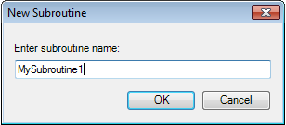
- Click OK.
A block of code for the subroutine called MySubroutine1 is created and displayed in the Check Code Editor. At this point, you can establish the check code commands to be incorporated into the subroutine. Make sure to Verify your code and Save once done.

Clear
CLEAR sets a field to a missing value, as though the field had been left blank. For example, it is useful to clear a previous entry in a field after an error has been detected. The CLEAR command can be followed by a GOTO command in order to place the cursor back into the field for further entry after an error. In the example below, the Date of Interview field is cleared after the user is notified that the date value entered is greater than today’s date.

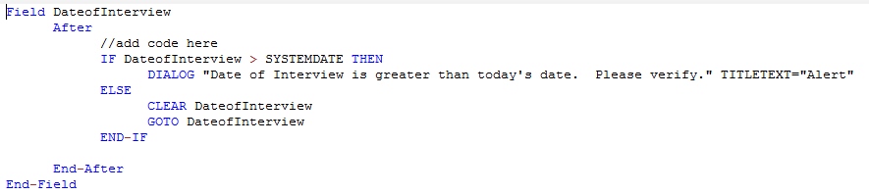
Figure 3.55: Check code syntax for CLEAR command

Define
This command creates a new variable. In Check Code, all user-defined variables are saved in the DEFINEVARIABLES section.
The proper syntax is:
DEFINE <variable name> {<scope>} {<field type indicator>}
- <variable name> represents the name of the variable to be created. <variable> cannot be a reserved word. For a list of reserved words, see the List of Reserved Words section of the User’s Manual.

- <scope> is optional and is the level of visibility and availability of the new variable. This parameter must be one of the reserved words: STANDARD, GLOBAL, or PERMANENT. If omitted, STANDARD is assumed and a type indicator cannot be used.
- <field type indicator> is the data type of the new variable and must be one of the following reserved words: NUMERIC, TEXTINPUT, YN, DATEFORMAT, TIMEFORMAT and DLLOBJECT. If omitted, the variable type will be inferred based on the data type of the first value assigned to the variable. Thereafter, the variable type cannot be changed. An attempt to assign data of a different type to the variable will result in an error.
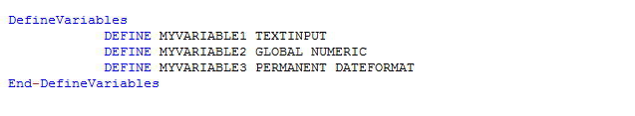
Figure 3.56: Check code syntax for DEFINE command
Below is a description for the optional SCOPE parameter used with the DEFINE command.
- STANDARD variables retain their value only within the current record and are reset when a new record is loaded. Standard variables are used as temporary variables behaving like other fields in the database.
- GLOBAL variables retain values across related forms and when a new form is opened by the program, but are removed when the Enter program is closed. Global variables persist for the duration of program execution.
- PERMANENT variables are stored in the EpiInfo.Config.xml file and retain any value assigned until the value is changed by another assignment or the variable is undefined. Permanent variables are shared among Epi Info modules (Enter, Classic Analysis, etc.) and persist even if the computer is shut down.

Enable/Disable These two commands usually work in conjunction. The DISABLE command disallows data entry into a field while the ENABLE command allows data entry into a previously disabled field.
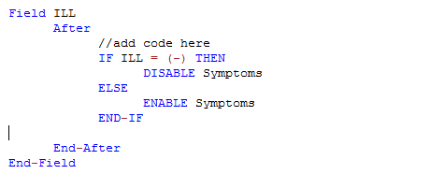
Figure 3.57: Check code syntax for ENABLE/DISABLE command

Execute Use to execute a Windows program.
Executes a Windows program - either one explicitly named in the command or one designated within the Windows registry as appropriate for a document with the file extension that is named. This provides a mechanism for bringing up whatever program is the default on a computer without first knowing its name. The EXECUTE command accepts a series of paths, separated by semicolons, as in:

EXECUTE c:\Users\MyPC\myfile.xls;d:\myfile.xls

If the first is not found, the others are tried in succession. In Check Code, the EXECUTE command can be placed in any command block, but is often used with a command button. Check code syntax is executed when the user clicks on the command button.
EXECUTE WAITFOREXIT "<filename>"EXECUTE NOWAITFOREXIT "<filename>"
- The <filename> represents the path and program name for .exe (filename for registered Windows programs) and .com (filename -DOS binary executables) files.
- The <command-line parameters> represent any additional command-line arguments that the program can accept.
- When Wait for Exit command is specified (modal), the command should run and Enter should continue running. When No Wait for Exit command is specified (non-modal), Enter should wait until the executed program closes before continuing. When EXECUTE is run modally, permanent variables are written before the command is executed and reloaded after the command is executed.
If the example below, the CDC website page is opened when the user clicks on a command button called OpenCDCWebsite. A .pdf file is automatically opened when the user clicks on a command button called OpenPDFdocument.
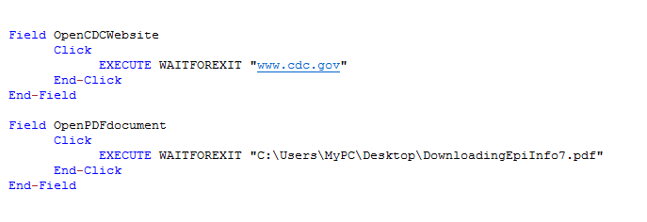
Figure 3.58: Check code syntax for EXECUTE command

Help
The Help command allows you to pop up a help window containing a message, or even a window on a large file that allows the user to move from one block of text to another by choosing highlighted portions of the text. This is a simple form of what is known as “hypertext.”

Highlight/Unhighlight
This command emphasizes the location of a field by highlighting in bright yellow, for example, if a data entry error was detected. It also unhighlights the field if needed. In the example below, the field Emergency is highlighted if the response to the field Vaccinated = “No”. All vaccinated questions are skipped and the field “Did you visit the emergency room?” is highlighted.

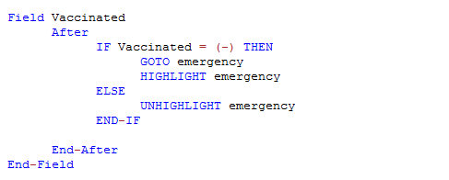
Figure 3.59: Check code syntax for HIGHLIGHT/UNHIGHLIGHT command

New Record
This command saves the current records data and opens a new record for data entry.

Figure 3.60: Check code syntax for NEWRECORD command

Quit This command allows the saving of the current record and closing of the Enter application.
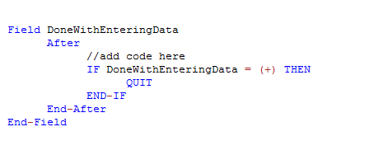
Figure 3.61: Check code syntax for QUIT command

Set-Required and Set-Not-Required
Sometimes users might want to set up a field as required only if a specific criterion is met. As with the REQUIRED property, if a field is set to required during data entry through check code, the Enter module will not allow further page navigation until a value has been entered into the field. In the example below, the field VaccinationDate is set as required if the Vaccination question is answered as Yes using the Set-Required command. Notice that the REQUIRE property has not been set during the creation of the field but it has been set with the check code. Once the criterion is met, the field is set back to its original state by using the Set-Not-Required command.
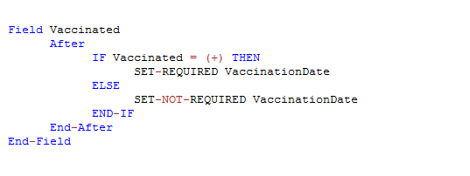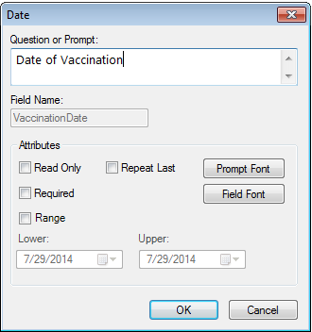
Figure 3.62: Check code syntax for SET-REQUIRED command

Check Features Covered Elsewhere - The Enter tool can be programmed to do many interesting and complex operations not discussed in this chapter, including mathematical and logical operations with more than one field, popping up help windows, and calling programs in other languages that act on the contents of fields during data entry.

How to use EpiWeek Function

Epidemiological weeks are usually complete weeks. The ministries of health around the world define the day of the week as the first epidemiologic day. As a result, some countries may consider Sunday as the first day of the week while others may consider the first day of the week to be either Saturday or Monday.

By default, Epi Info™ 7 marks Sunday as the beginning of the epidemiological week. However, the parameter for the Epiweek function can be modified in order to change the beginning of the epidemiological week as desired.

If the year of occurrence is not relevant, use the EpiWeek method instead. The advantage of using EpiWeek is that the value is returned as a number and it can be stored in a numeric field. EpiWeek takes one required parameter that must be a date. The week is calculated relative to the year of the date provided. The Epidemiological week is calculated using the following code:

ASSIGN MyEpiWeek = EPIWEEK( <start_date>, {<first_day_of_week>} )

The example below shows the check code needed for automatically calculating the corresponding Epi Week into a field called SurveillanceWeek based on the value entered in a date field called OnsetDate.
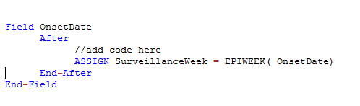
Figure 3.63: Check code syntax for EPIWEEK function

In the other hand, if you are required to modify the first day of the week parameter because the week does not start on a Sunday, the check code syntax would need to be updated. In the example below, the epidemiological week will be calculated based on a starting day of Monday (i.e. Sunday will be 1, Monday will be 2, Tuesday will be 3, etc.)
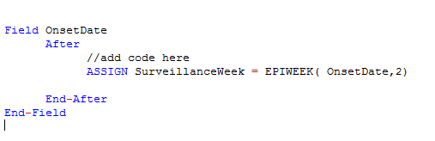
Figure 3.63: Check code syntax for EPIWEEK function with beginning week parameter

Proper Check Code Syntax

Using the proper check code syntax is important based on the field type. Here are some examples of the proper syntax to use based on the field type;
- Assign the ‘Age’ field (numeric field type) the value 24
  - ASSIGN Age = 24

- Assign the ‘Ill’ field (Yes/No field type) the value No
  - ASSIGN Ill = (-)

- Assign the ‘AteChicken’ field (checkbox field type) the value Yes
  - ASSIGN AteChicken = (+)

- Assign the ‘DateOfInterview’ field (Date field type) the value 5/5/2012
  - ASSIGN DateOfInterview = 5/5/2012

- Assign the ‘CaseStatus’ field (legal values field type) the value “Confirmed”
  - ASSIGN CaseStatus = "Confirmed"

- Assign the ‘Gender’ field (Comment Legal field) the value “F”. The field is coded as M-Male, F-Female.
  - ASSIGN Gender = "F"

